SFP STUDENT PARTICIPATION TRACKING TOOLS
Paper Tracking Tools:

1.Grab & Go Program Tracking Tool
This template is for tracking student participation in grab-and-go programs, where students take food items or pre-packed meals or snacks without plates. Use this tally sheet before and during each meal service (breakfast, snack or lunch). As described in Nova Scotia’s School Healthy Eating Program (see Appendix A), participation can be recorded by (a) marking a paper tally sheet (template below) (b) using a handheld counter/clicker, or (c) using a phone counting app.

Instructions:
- Record first servings separately from repeat servings (seconds/thirds) to accurately capture both unique students served and total meals served.
- Add repeat servings (seconds/thirds) to first servings for the total meals served.
- Use the Notes column to record relevant contextual factors (i.e., numerous students absent, menu changes, missing ingredients, weather impacts) and justification for the number of meals served. For example, on very cold days, school attendance numbers decrease, resulting in lower numbers at lunchtime.

Example: Grab & Go Tracking Tool
Date | Meal Type (foods prepared) | Number of servings prepared | First Servings | Second and Third Servings | Unique Students Served | Notes (e.g., extreme weather)
Sept 17, 2025 | Breakfast  (yogurt, granola and mixed berries) | 50 |  |  | 40
Sept 17, 2025 | Lunch  (ham and cheese sandwich with side salad) | 50 |  |  | 45

2.Bin Program
This template is for tracking student participation in bin programs where breakfast, snacks or lunches are delivered to classrooms or made available in central school locations, e.g., school entrance. Use this log before and after each meal service. For additional tips on operating a bin program, see Breakfast Club of Canada’s Classroom Delivery Guide.

Tracking Food Variety: Label each bin with the types of food provided (i.e., fruit, vegetable, protein, and/or whole grain). Use dry erase markers on laminated, reusable labels to record the number of each food item provided in the bin. Figure 1: Meal/Snack Bin Label (printable labels from BCC).
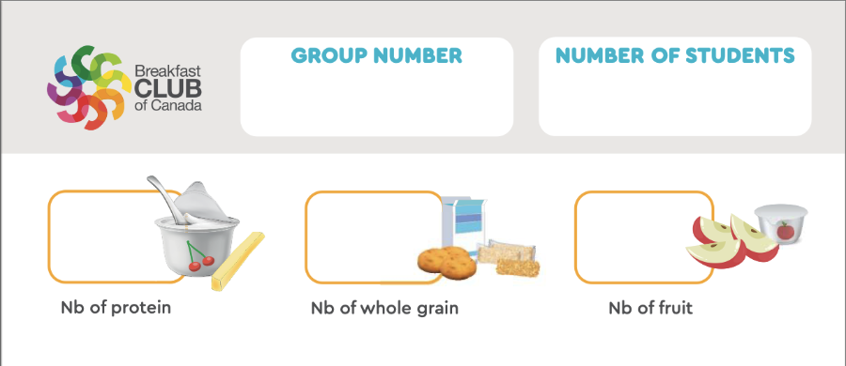

Tracking participating students: Send a comment card with each bin for teachers to record the number of participating students. To make participation easy to track, students can note their participation by taking a Lego piece, or other items (e.g., erasers) and placing it into an empty container when they take food. Some students may only choose to take a portion of the meal on offer (e.g., they brought a granola bar from home but wanted to have some fruit too); this counts as participation. Teachers can also use the comment card to share student food preferences (e.g., “Our class loved the strawberries - please send extra next week”) to support menu planning.

Instructions:
- Record the number of food items prepared and the number of items uneaten.
- Subtract uneaten items from prepared items to calculate the number of food items consumed.
- Tally all the comment cards noting student participation to calculate the total number of participating students.
- Use the Notes column to record relevant contextual factors (i.e., numerous students absent, menu changes, missing ingredients, weather impacts) and justification for the number of meals served. For example, on very cold days, school attendance numbers decrease, resulting in lower numbers at lunchtime.

Example: Bin Program
Date | Meal Type (foods prepared) | Number of servings or food items prepared | Number of servings of food items uneaten | Unique Students Served (tallied from Comment Cards) | Notes (e.g., extreme weather)
Sept 17, 2025 | Breakfast  (yogurt, granola and mixed berries) | 50 | 5 | 45
Sept 17, 2025 | Lunch  (ham and cheese sandwich with side salad) | 50 | 5 | 45

3.Sit-down / Plated Meal Program
This template is for cafeteria-style or plated meal service. Use this log before and after each meal service. As described in Nova Scotia’s School Healthy Eating Program (see Appendix A), participation can be recorded by (a) marking a paper tally sheet (template below) (b) using a handheld counter/clicker, or (c) using a phone counting app.
Instructions:
- Record the number of meals prepared and the number of plates put out at the start of the meal service.
- Record first servings (unique students served) separately from repeat servings (seconds/thirds) to accurately capture both unique students served and total meals served.
- Add repeat servings (seconds/thirds) to first servings for the total meals served.
- Use the Notes column to record relevant contextual factors (i.e., numerous students absent, menu changes, missing ingredients, weather impacts) and justification for the number of meals served. For example, on very cold days, school attendance numbers decrease, resulting in lower numbers at lunchtime.

Example: Sit-Down / Plated Meal Program
Date | Meal Type (foods prepared) | Number of Servings Prepared | Number of plates put out at start of service | First Servings | Second and Third Servings | Unique Students Served | Notes (e.g., extreme weather)
Sept 17, 2025 | Breakfast (yogurt, granola and mixed berries) | 60 | 50 |  |  | 45
Sept 17, 2025 | Lunch (ham and cheese sandwich with side salad) | 60 | 50 |  |  | 50

Additional Tips and Staff Guidance on Plate Counting Methods:
Each plate or container counts as one meal served; ensure students use a fresh plate for each serving. Be aware that meals taken as only fruits/vegetables may not be captured unless noted. There are three plate/container counting methods:
Method 1: Set out a pre-determined number of plates or containers and subtract the number of plates that aren’t used from the total to get the total meals served. Instruct students to use a fresh plate with each trip to get food. Consider also using a sheet to record the date, the name of meal served, the number of plates, and justification for the number of meals served. For example, on very cold days, school attendance numbers decrease, resulting in lower numbers at lunchtime.

Method 2: Use the plate count method described in Method 1 to account for first servings (number of unique students served) and on a sheet of paper to tally the number of seconds and thirds taken (number of meals served). Add the number of plates taken to the number of checks/tally of seconds and thirds for the total number of meals served. At the end of service, optionally count plates in the dishwasher to cross-check totals.

Method 3: Count the number of plates put into the dishwasher at the end of meal service. Use the number of plates as the number of meals served.

Electronic Tracking Tools:
4. Online Meal Ordering/Payment System:

Description: Parents order meals in advance, either at full-price, reduced-price, or free, using an online platform, e.g., Pay-What-You-Can (PWYC) order systems in PEI and NL.

Ideal Context to use this method:
- Regional programs that would be supported by centralized tracking of meals

Limitations:
- There could be technological barriers to access for families
- Because of the anonymous online platform parents may be less inclined to “pay what they can” regardless of income
- The rising cost of living also puts downward pressure on parental contributions, which threatens program sustainability if the expected parental portion of program costs isn’t contributed.

5. Point-of-Sale (POS) System:

Description: A point-of-sale system is a computer system that is often seen in a cafeteria checkout lane. Each student has a unique and anonymous ID linked to their RFID tag, student ID card, or unique student 4-digit PIN. This system is common in the United States where it is used to track meals for federal reimbursement.
Ideal context to use this method:
- Regional programs that would be supported by centralized tracking of meals
- Large high school cafeterias serving hundreds of students

Limitations:
- Space for POS system required in cafeteria
- Personnel needed to operate POS system
- Students, especially younger students, may lose the tag or card or forget their PIN
- Doesn’t work in a classroom setting
- Requires costly software systems and equipment; however, the tags themselves are relatively affordable. Someone also needs to manage the system’s data and repair it if/when it malfunctions.

Glossary
Meals prepared: total number of complete meals prepared that include all meal components.
Food items prepared (for bin program): total number of individual food items packed in bin, e.g., yogurt tube, apple, banana = 3 items
Meals served: total number of complete meals served to students. Typically, less than the number of meals prepared.
Food items uneaten (for bin program): total number of food items returned uneaten in bins, e.g., yogurt tube, apple, banana = 3 items – returned in bin
Unique Students Served / Participating Students: number of students who participated in the school food program to any degree, whether they received a full meal or selected only one food item. Typically, this does not equal the number of meals served or food items taken, as a student may, for example, bring a granola bar from home but choose to take a piece of fruit from the program. In this case, the student did not consume a full school meal/snack, but they did participate in the program. The number of students participating does NOT equate to the number of students that had access to the program (i.e. the whole school population).

